AI RESEARCH AND DOCUMENT ASSISTANT
Submitted By
Kiran Rajan G
Project Type
Generative AI / RAG Application
Technologies
Python | LangChain | LangGraph | RAG | ChromaDB | Hugging Face Embeddings | Groq LLM | Prompt Engineering | LangSmith | FastAPI | LangServe | Streamlit

1. ABSTRACT
The AI Research and Document Assistant is a Retrieval-Augmented Generation (RAG) based application designed to allow users to upload documents, retrieve relevant information, ask questions, generate document summaries, and compare multiple documents.
The system processes PDF documents by extracting their textual content, splitting the text into smaller chunks, generating vector embeddings, and storing the embeddings in a Chroma vector database. When a user asks a question, the system retrieves the most relevant document chunks and provides them as context to a Large Language Model (LLM).
LangGraph is used to orchestrate the workflow involving document retrieval, answer generation, grounding verification, retry handling, and final response generation. A hallucination-checking mechanism evaluates whether the generated answer is supported by the retrieved context.
The application also integrates LangSmith for tracing and debugging, FastAPI and LangServe for API-based access, and Streamlit for the final user interface.
The system was evaluated using 25 questions across normal, multi-document, unanswerable, ambiguous, and hallucination-testing categories. The application achieved an overall 76% grounding rate.
2. INTRODUCTION
With the increasing availability of digital documents, users often need to search through large amounts of information to find specific answers. Traditional keyword-based search can return relevant documents but does not directly generate contextual answers.
Large Language Models can generate natural-language responses, but they may produce information that is not present in the source documents. This problem is commonly known as hallucination.
The AI Research and Document Assistant addresses this problem by combining:
- Document processing
- Text chunking
- Vector embeddings
- Vector database retrieval
- Retrieval-Augmented Generation
- Prompt engineering
- LangGraph workflow orchestration
- Grounding verification
- LLM-based answer generation
- Evaluation
- LangSmith tracing
- FastAPI
- LangServe
- Streamlit
The application therefore provides a complete document intelligence workflow from document upload to grounded answer generation.
3. OBJECTIVES
The main objective of the project is to build an AI-powered document assistant that can retrieve information from uploaded documents and generate answers based only on the available document context.
Specific objectives:
- Load and process PDF documents.
- Extract textual information from documents.
- Split large documents into manageable chunks.
- Generate embeddings for document chunks.
- Store embeddings in a vector database.
- Retrieve relevant document chunks based on user questions.
- Generate answers using an LLM.
- Reduce hallucinations through context-based prompting.
- Verify whether generated answers are supported by retrieved context.
- Implement retry and conditional routing using LangGraph.
- Support document summarization.
- Support comparison of two documents.
- Evaluate the system using different question categories.
- Trace application execution using LangSmith.
- Expose the RAG workflow through FastAPI and LangServe.
- Provide a user-friendly Streamlit interface.
4. PROBLEM STATEMENT
Users often need to analyze multiple documents and extract specific information from them. Manually searching through lengthy documents is time-consuming and inefficient.
Although LLMs can answer questions in natural language, directly asking an LLM questions about a specific document can result in unsupported or hallucinated answers.
Therefore, the problem is to develop a system that:
- Accepts user documents.
- Extracts and processes their content.
- Retrieves relevant information.
- Generates answers using the retrieved context.
- Provides source information.
- Identifies unsupported answers.
- Handles questions whose answers are not available in the documents.
- Supports multiple document-based operations.
5. TECHNOLOGY STACK
Technology | Purpose
Python | Core programming language
LangChain | RAG and LLM application framework
LangGraph | Workflow orchestration
ChromaDB | Vector database
Hugging Face | Embedding model
Sentence Transformers | Document embeddings
Groq | LLM inference
GPT-OSS-120B | Selected Groq LLM
PyPDF | PDF document loading
Streamlit | User interface
FastAPI | API development
LangServe | Serving LangChain/LangGraph applications
LangSmith | Tracing and evaluation
Pandas | Evaluation dataset processing
python-dotenv | Environment variable management

6. SYSTEM ARCHITECTURE
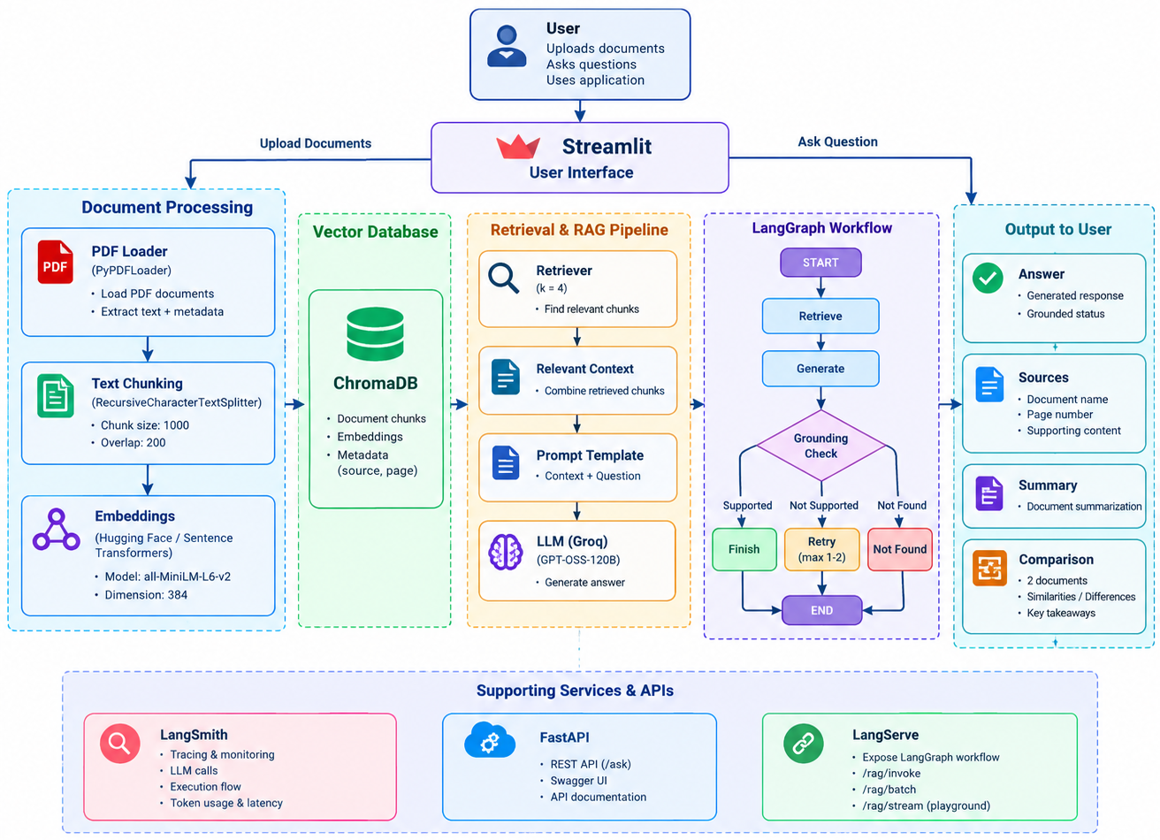
7. DATASET / DOCUMENTS USED
The application was tested using four related PDF documents:
- BERT.pdf
- LanguageModels.pdf
- RAG.pdf
- Transformers.pdf
These documents were selected because they are related to Natural Language Processing, Transformers, Language Models, BERT, and Retrieval-Augmented Generation.
The initial document-processing test loaded:
125 pages
After text splitting, the documents produced: 544 chunks
8. RAG PIPELINE
Question
↓
Retriever
↓
Relevant Document Chunks
↓
Context
↓
Prompt Template
↓
LLM
↓
Answer
Detailed process
Step 1 — User Question
Example:
What is Retrieval-Augmented Generation?
Step 2 — Retrieval
The retriever searches the Chroma vector database.
Step 3 — Context Creation
The retrieved chunks are combined into a context.
Step 4 — Prompt Construction
The context and question are inserted into the QA prompt.
Step 5 — LLM Generation
The Groq-hosted LLM generates the answer.
Step 6 — Source Extraction
The application returns:
- Answer
- Source document
- Page number
- Supporting content.
9. LANGGRAPH WORKFLOW
LangGraph is used to control the RAG workflow.
The workflow contains:
START
↓
Retrieve
↓
Check Retrieval
↓
Generate Answer
↓
Grounding Check
↓
┌───────────────┬───────────────┐
│ │ │
Supported Retry Not Found
│ │ │
▼ ▼ ▼
END Generate END
Again

10. EVALUATION
10.1 EVALUATION METHODOLOGY
The application was evaluated using:
25 questions
The questions were divided into five categories:
- Normal
- Multi-document
- Unanswerable
- Ambiguous
- Hallucination testing
This evaluation was designed to test both normal functionality and failure-handling behavior.
10.2. EVALUATION DATASET
The evaluation dataset contains questions covering:
Normal Questions
Questions for which answers should be available in the documents provided.
Multi-document Questions
Questions requiring information or relationships across multiple documents.
Unanswerable Questions
Questions whose answers are not contained in the documents provided.
Ambiguous Questions
Questions where the wording can have multiple interpretations.
Hallucination Testing
Questions designed to determine whether the system produces unsupported information.

10.3. EVALUATION RESULTS
The actual evaluation produced:
Metric | Result
Total Questions | 25
Grounded Answers | 19
Ungrounded Answers | 6
Overall Grounding Rate | 76.00%
Results by question type
Question Type | Grounded | Total | Grounding Rate
Normal | 9 | 10 | 90.00%
Multi-document | 5 | 5 | 100.00%
Unanswerable | 1 | 5 | 20.00%
Ambiguous | 2 | 3 | 66.67%
Hallucination Test | 2 | 2 | 100.00%
10.3. EVALUATION ANALYSIS
The system achieved an overall grounding rate of:
76.00%
The strongest performance was observed in multi-document questions, where the system achieved:
100.00%
The hallucination-testing category also achieved:
100.00%
Normal questions which were answered:
90.00%
Ambiguous questions which were answered:
66.67%
The lowest performance occurred for unanswerable questions:
20.00%
This indicates that the system can answer document-based questions effectively in many cases, but the handling and detection of questions whose answers are completely absent from the documents requires further improvement.
The evaluation demonstrates that the system was tested across multiple scenarios rather than only successful question-answering cases.
11. CHALLENGES
- Large Document Processing: Large documents can exceed the LLM's context or request limits.
- LLM Request Size: Large summary requests resulted in request-size limitations.
- API Rate Limits: Multiple LLM requests in a short period can result in rate-limit errors.
- Hallucination: An LLM may generate information not supported by documents.
- Unanswerable Questions: The system needs to distinguish between available and unavailable information.
- API Integration: The RAG workflow needed to be accessible outside Streamlit.
12. SCREENSHOTS
- Document Upload
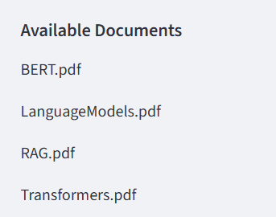

- Question Answering
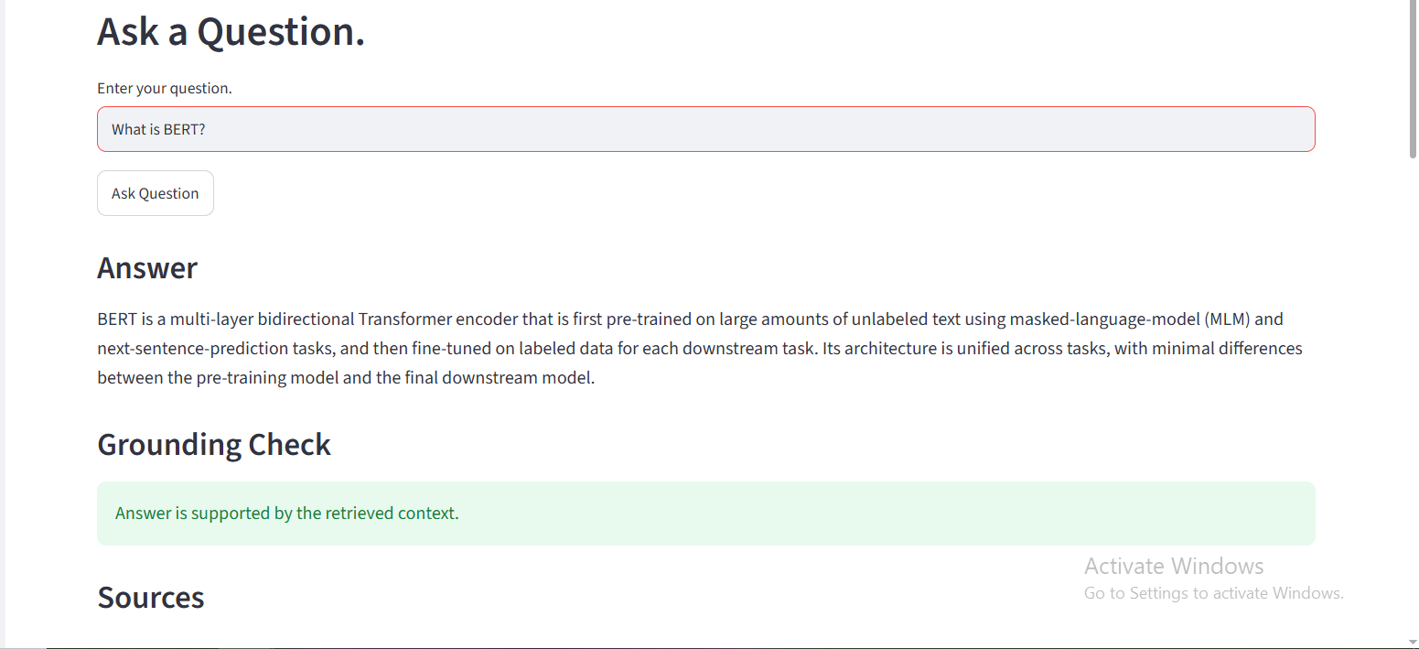
- Sources
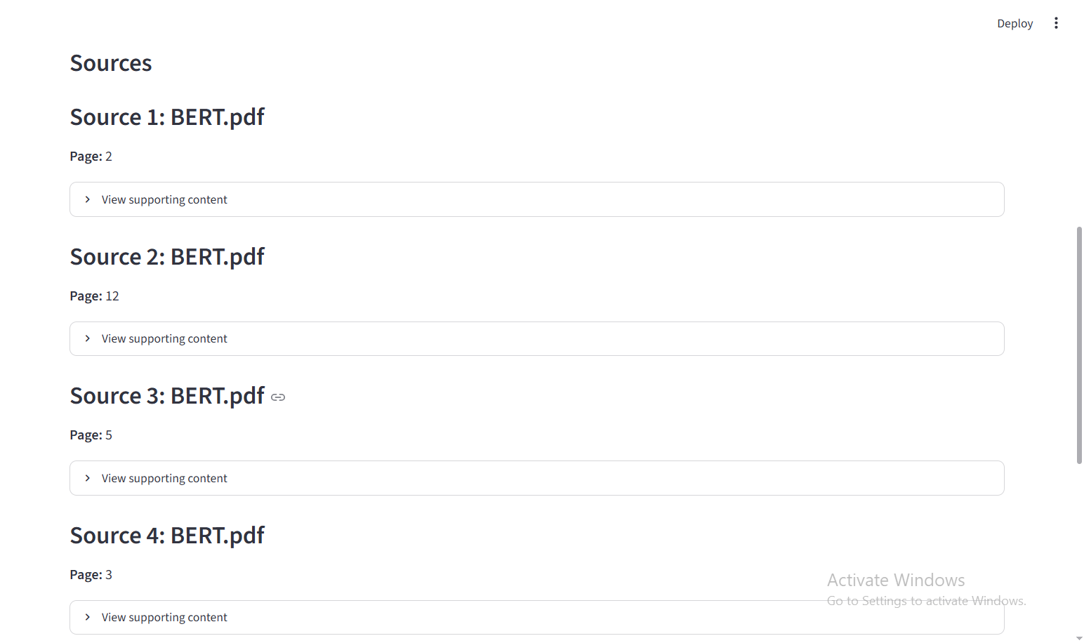

- Unanswerable Question
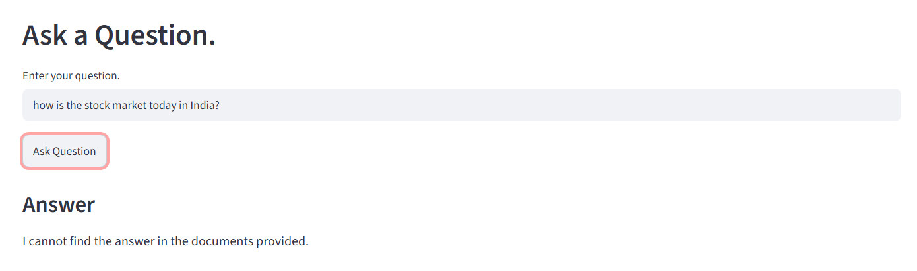

- Document Summary
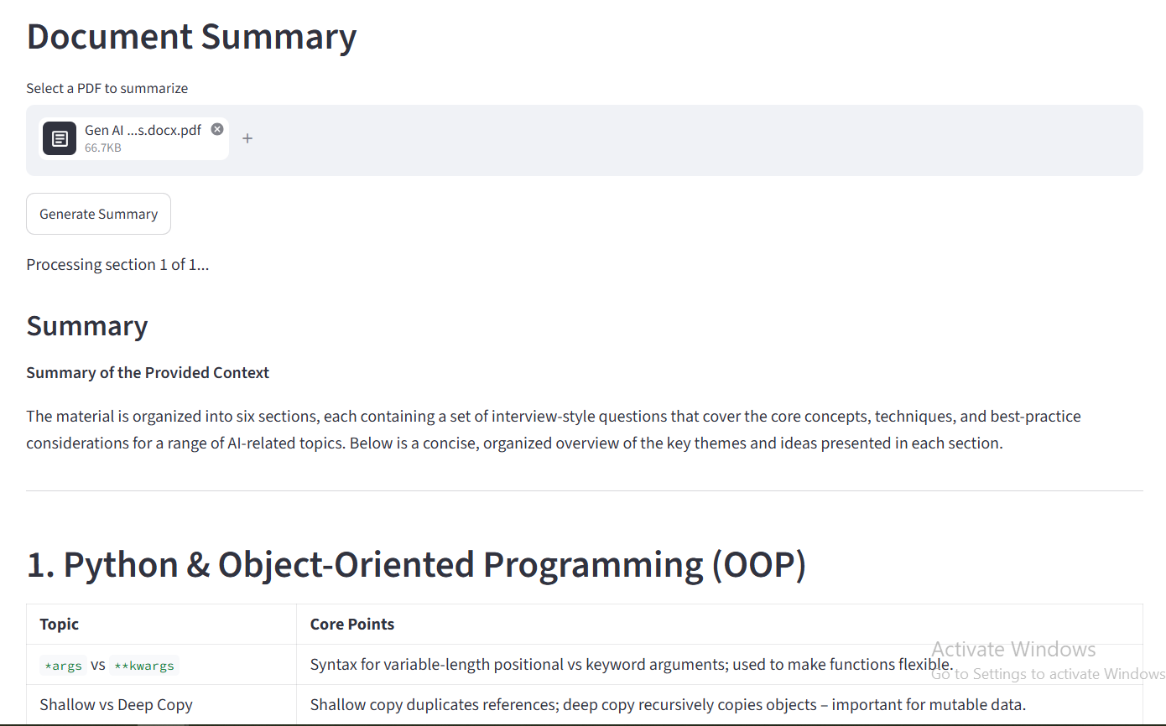
- Document Comparison
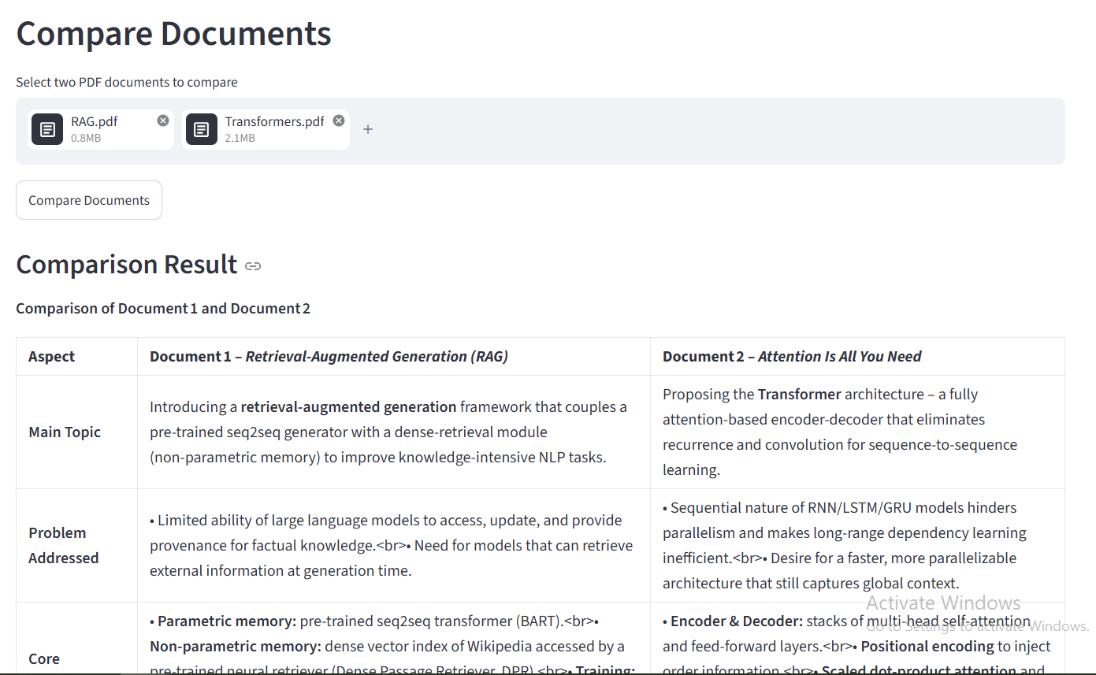

- LangGraph

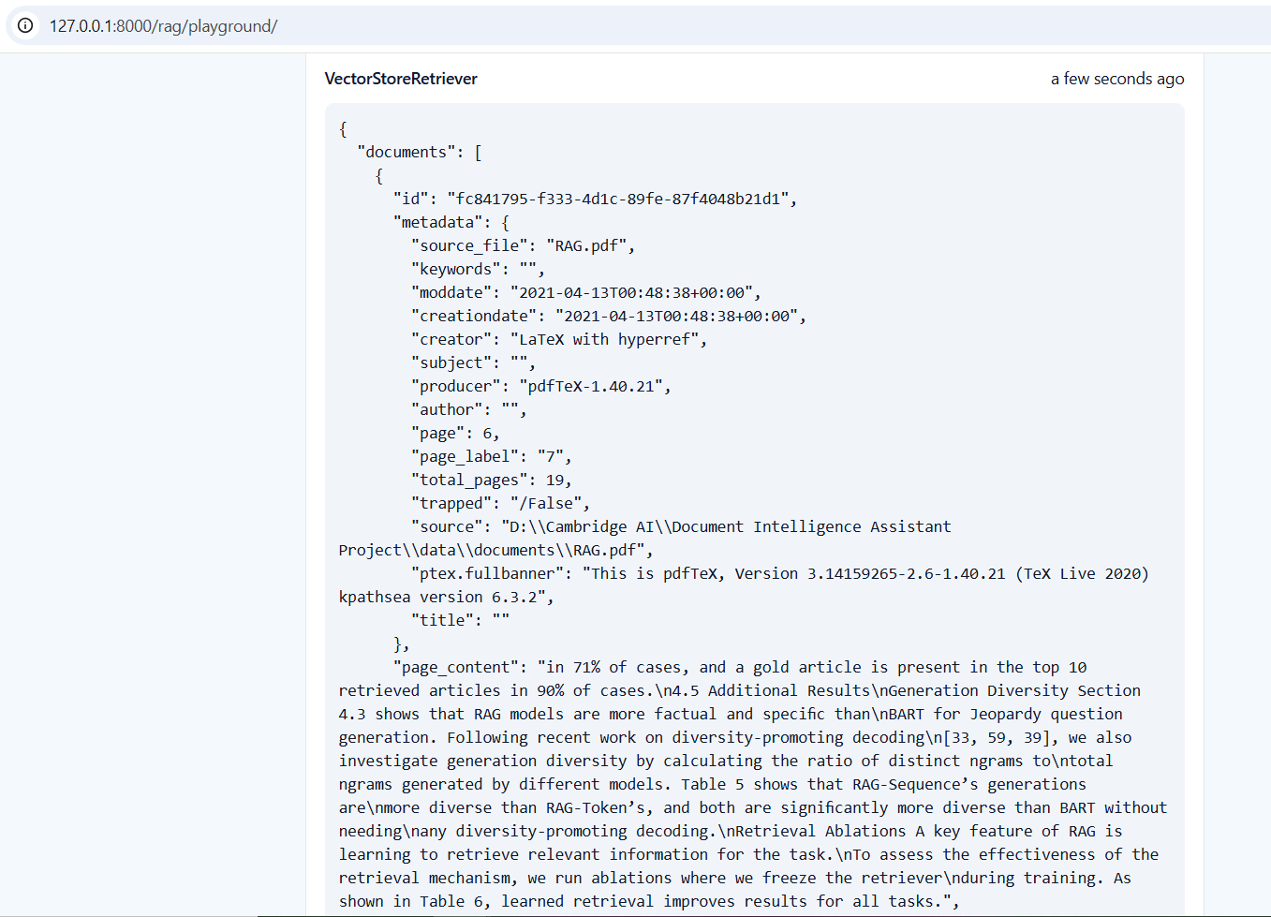

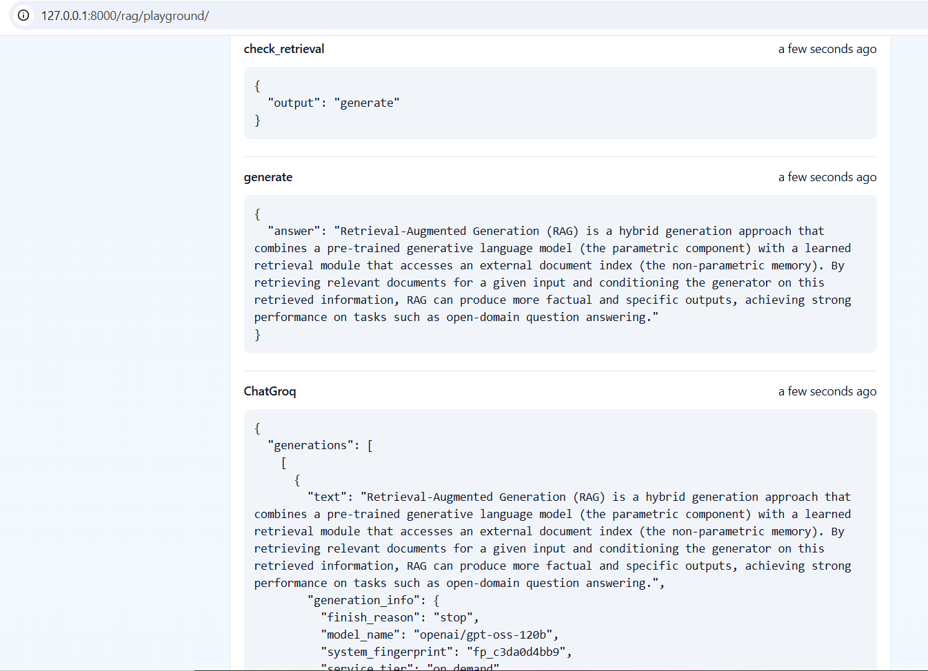

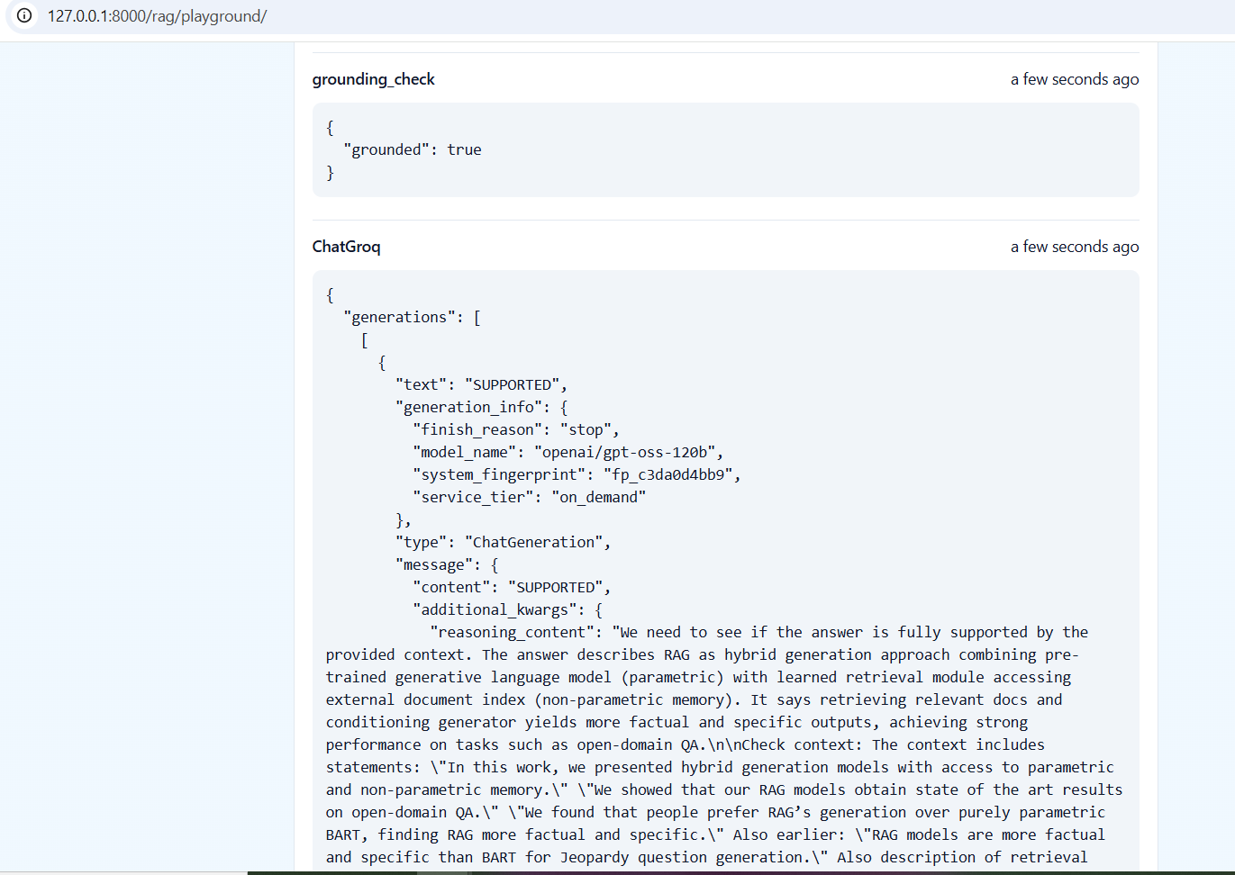

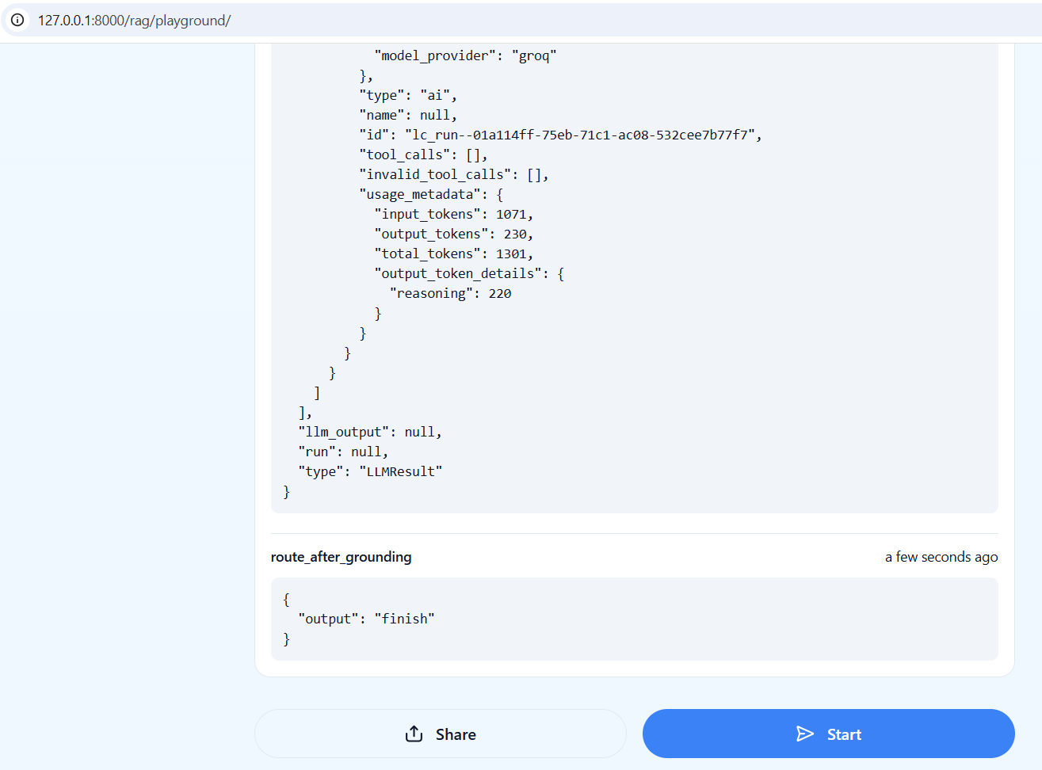

- LangSmith

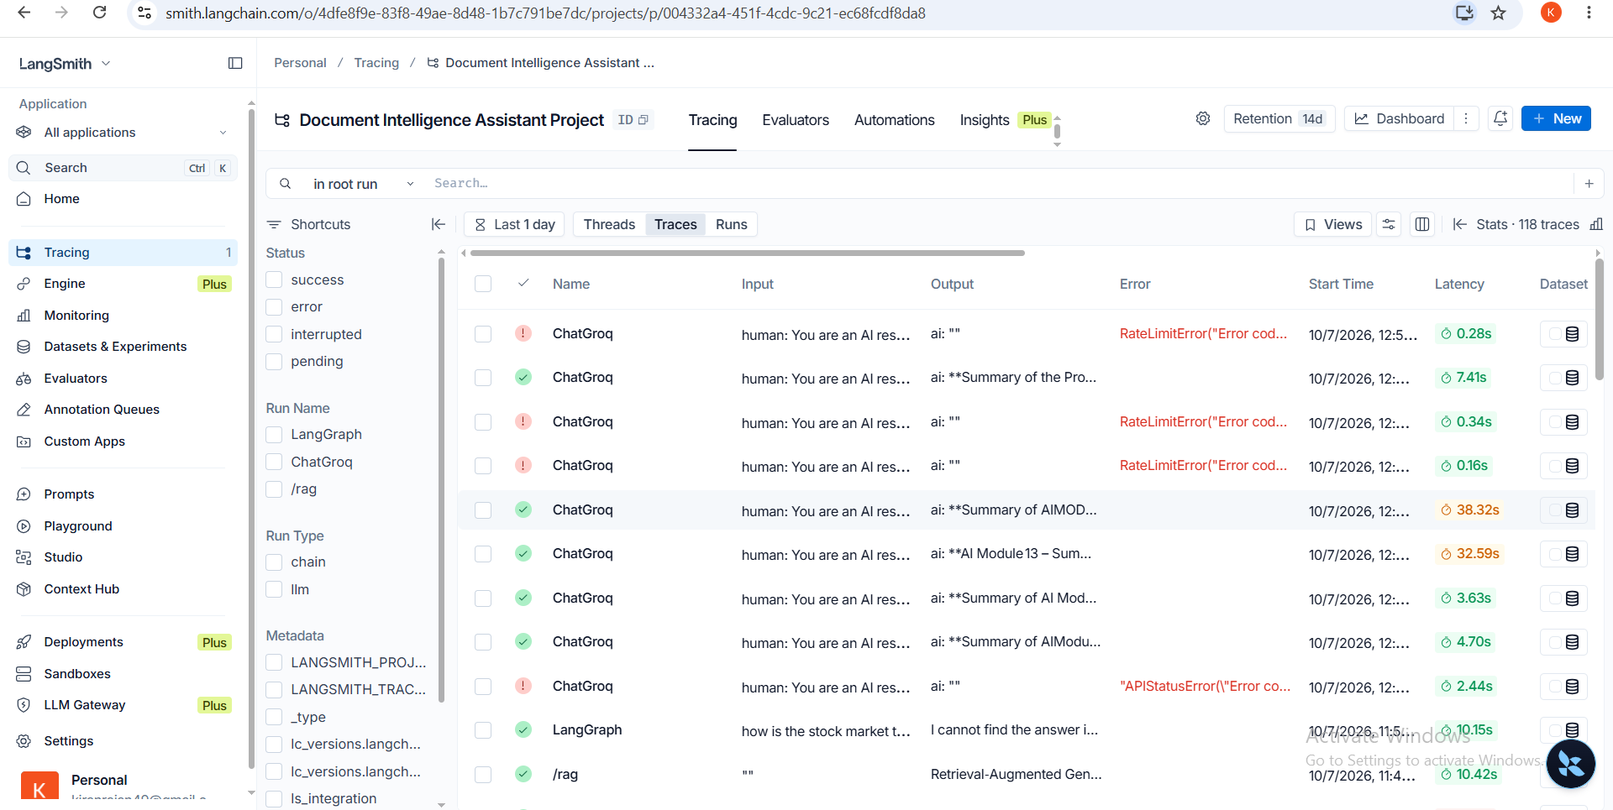

- Evaluation Results
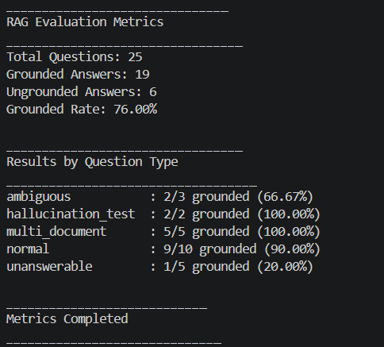

- Swagger
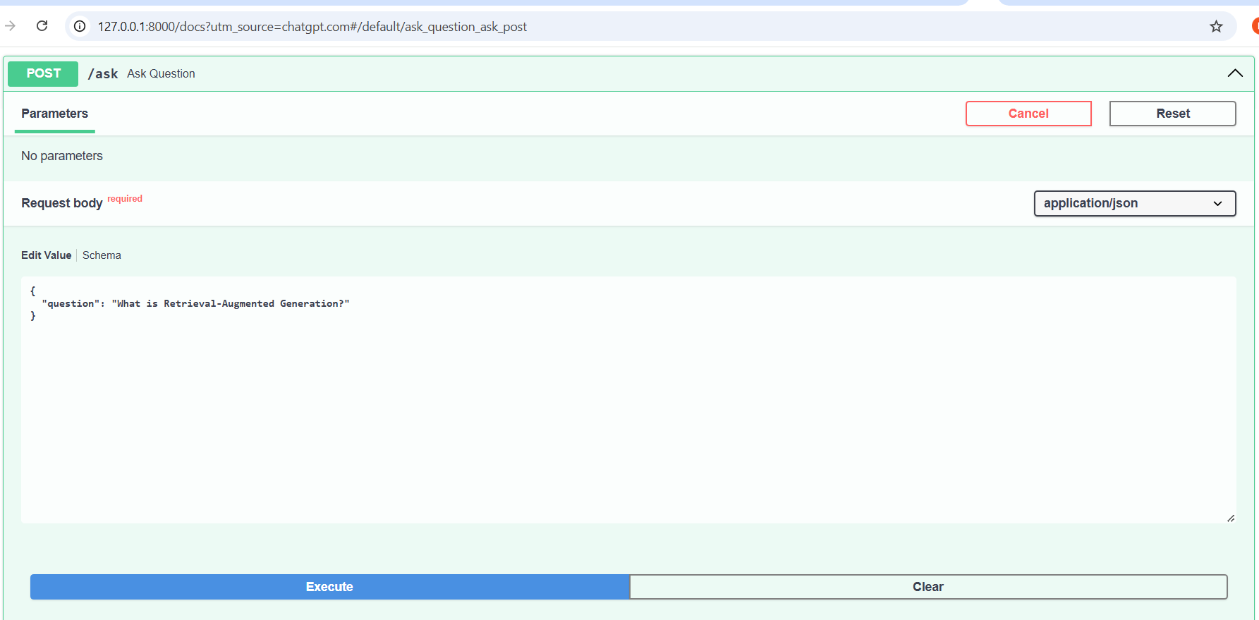
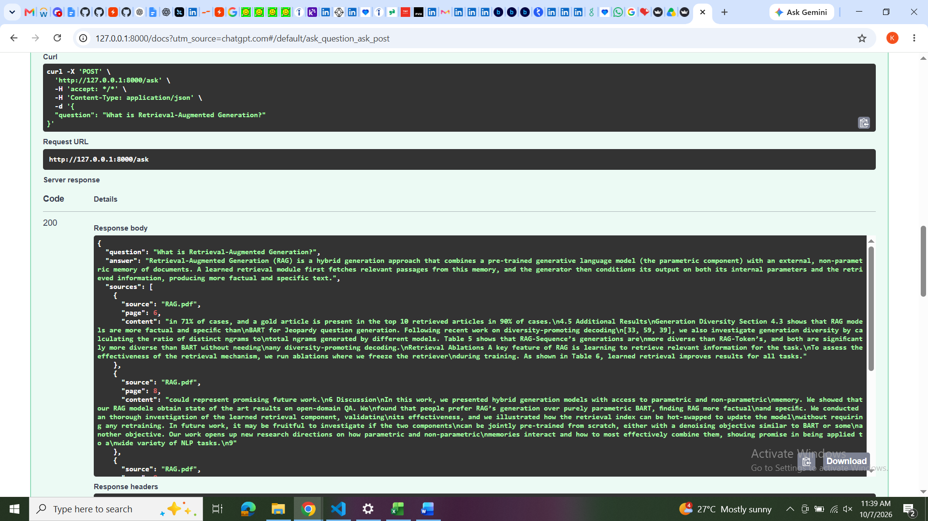
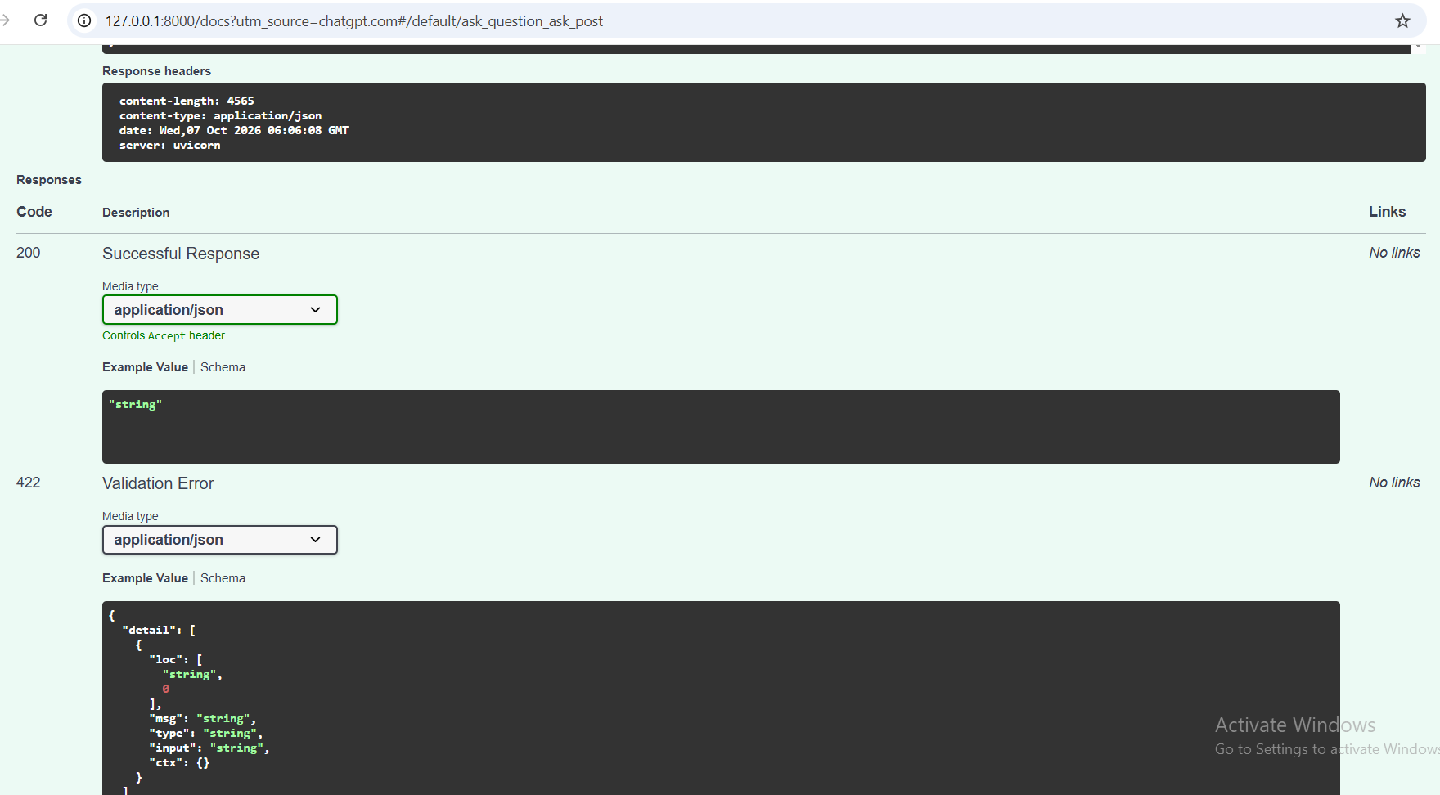

- LangServe Playground
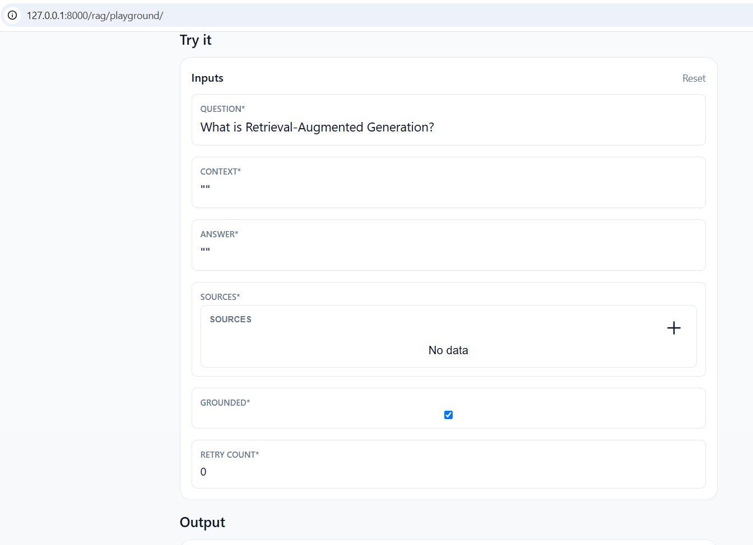

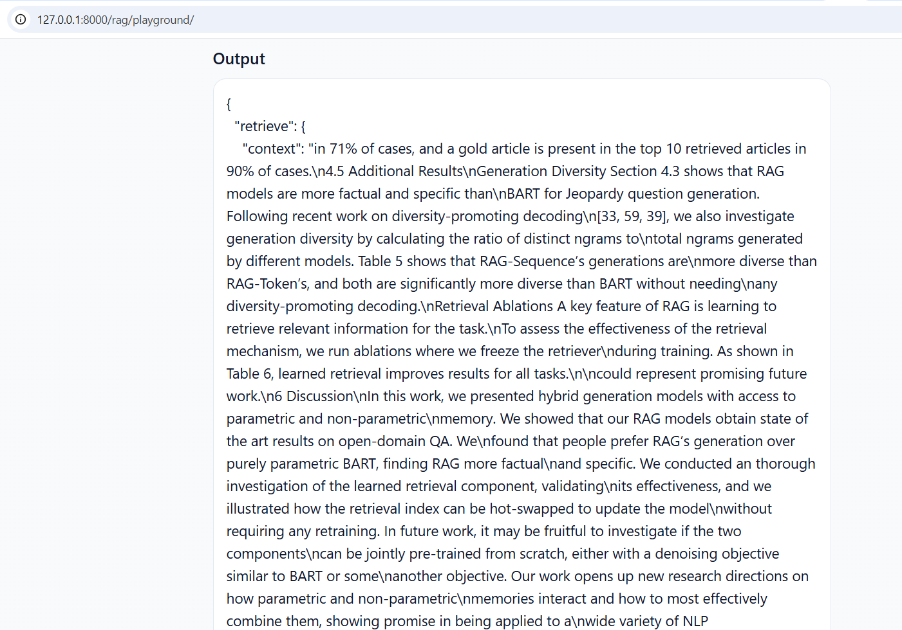

13. RESULTS
The completed system successfully integrates the major technologies required for the project.
The application can:
- Process PDF documents.
- Split documents into chunks.
- Generate embeddings.
- Store embeddings in ChromaDB.
- Retrieve relevant document content.
- Generate context-based answers.
- Display sources.
- Perform grounding checks.
- Handle unanswerable questions.
- Retry unsupported generations.
- Summarize documents.
- Compare documents.
- Expose the RAG workflow through FastAPI.
- Serve the workflow using LangServe.
- Trace application execution using LangSmith.
- Provide a complete Streamlit interface.
The evaluation produced a 76% overall grounding rate across 25 questions.
14. CONCLUSION
The AI Research and Document Assistant demonstrate how modern Generative AI technologies can be combined to create a practical document intelligence application.
The project implements a complete RAG pipeline involving document processing, chunking, embeddings, vector storage, retrieval, prompt engineering, and LLM-based generation.
LangGraph provides workflow orchestration and conditional routing, while the grounding-check mechanism helps reduce unsupported answers. LangSmith provides tracing and monitoring capabilities, and FastAPI and LangServe make the RAG workflow accessible through APIs.
The Streamlit interface provides users with an accessible way to upload documents, ask questions, view sources, summarize documents, and compare documents.
The system was evaluated using 25 questions across multiple categories and achieved an overall 76% grounding rate, with particularly strong performance on multi-document and hallucination-testing questions.
Overall, the project demonstrates the practical implementation of a complete RAG-based AI research and document assistant using Python and the LangChain ecosystem.

